**“Carrer Guidance Management System”**



**A**

**PBL Report Submitted to the**

**SAGE University, Bhopal, M.P.**

**in partial ful fillment of the requirements for the award of the Degree of BTech CSE**

**II Semester By**

**PRIYANSHU VERMA [23BTE3CSE10142] SANCHIT CHORGHADE [23BTE3CSE10172]**

**Under the Guidance of**

**Mr. Atesh Singh**

**Assistant Professor**

**SSOET**

**SCHOOL OF ENGINEERING AND TECHNOLOGY SANJEEV AGRAWAL GLOBAL EDUCATIONAL UNIVERSITY, BHOPAL**

**AUTUMN 2023-24**

### SANJEEV AGRAWAL GLOBAL EDUCATIONAL UNIVERSITY BHOPAL

**SCHOOL OF ENGINEERING AND TECHNOLOGY**

### CERTIFICATE

This is to certify that the work embodies in this project entitled “**CARRER GUAIDANCE MANAGEMENT SYSTEM”** being submitted byPriyanshu Verma [23BTE3CSE10142] , Sanchit Chourghade [23BTE3CSE10172]in partial fulfillment of the requirement for the award of the degree of **BTech CSE** to School of Engineering And Technology, Sanjeev Agrawal Global Educational University, Bhopal (M.P) during the academic year **2024-25** is a record of bonafide piece of work, undertaken by him under the supervision of the undersigned.

.

**Mr. Atesh Singh Dr Mukesh Dixit**

**SSOET HOD, SOET**

**(GUIDE)**

### SANJEEV AGRAWAL GLOBAL EDUCATIONAL UNIVERSITY, BHOPAL

**SCHOOL OF ENGINEERING AND TECHNOLOGY**

**CERTIFICATE OF APPROVAL**

The Project entitled “**Carrer Guidance Management System ”** being submitted by has been examined by **Priyanshu Verma** [23BTE3CSE10142], **Sanchit Chorghade** [23BTE3CSE10172], us and is hereby approved for the award of the degree of **BTech CSE,** for which it has been submitted. It is understood that by this approval the undersigned do not necessarily endorse or approve any statement made, opinion expressed, or conclusion drawn there in, but approve the project only for the purpose for which it has been submitted.

(Internal Examiner) (External Examiner)

### SANJEEVAGRAWALGLOBALEDUCATIONALUNIVERSITY, BHOPAL

**SCHOOL OF ENGINEERING AND TECHNOLOGY**

### DECLARATION

**DECLARATION**

I hereby declare that the work, which is being presented in this project entitled “**Carrer Guidance Management System ”**for fulfillment of the requirements for the award of the degree of **BTech CSE** submitted in the School of Engineering And Technology, Sanjeev Agrawal Global Educational University, Bhopal, M.P. is an authentic record of my own work carried under the guidance of “**Mr. Atesh Singh”**. I have not submitted the matter embodied in this report for the award of any other degree.

I also declare that “A check for Plagiarism has been carried out on this report and is found within the acceptable limit."

**PRIYANSHU VERMA [23BTE3CSSE10142], SANCHIT CHORGHADE [23BTE3CSE101772]**

**SANJEEV AGRAWAL GLOBAL EDUCATIONAL UNIVERSITY, BHOPAL**

**SCHOOL OF ENGINEERING AND TECHNOLOGY**

**ACKNOWLEDGEMENT**

It is my proud privilege to present a project on “**Carrer Guidance Management System”.** I take this opportunity to express deep sense of gratitude and would like to give thanks to my guide, “**Mr. Atesh Singh”, Assistant Professor,** School of Engineering And Technology, Sanjeev Agrawal Global Educational University, Bhopal, M.P. for his valuable guidance, inspiration and encouragement that has led to successful completion of this work.

I would like to express my heartfelt thanks towards **Dr Mukesh Dixit, HOD, School of Engineering And Technology** . I could not have accomplished, what I actually have, without their guidance. I would like to express my heartfelt thanks to **Dr. Mukesh Dixit, HOD, School of Engineering And Technology,** for his valuable suggestions throughout the project work.

I would like to express my heartfelt thanks and sense of gratitude to “**Mr. Atesh Singh”** for being a constant source of inspiration. I am also thankful to all faculty members and staff of School of Engineering and Technology for their suggestions and support.

I would like to deeply thank my family and friends for all the support and encouragement they have rendered time to time.

Last but not the least, I dedicate my work to almighty God without whose wish and helping hands this work would not have taken the shape it has now and also to my family members whose support and encouragement had led me to complete this task.

**Priyanshu Verma** [23BTE3CSE10142]

**Sanchit Chorghade** [23BTE3CSE10172]

# ABSTRACT

Career Guidance is very important to our Educational System. We have an existing Manual Career Guidance System with human counselors in charge, but this system is plagued with the following problems: few number of human counselors, unavailability of a counselor in a good number of schools, few number of counselors attending to students during school hours and the office of a counselor in schools are so unpopular that students hardly meet them for career counseling. We have been able to design an Online Career Guidance Information System targeting students in pre tertiary institutions in Nigeria to solve the afore- mentioned problems. The Online Web Based Career Guidance system was designed and implemented using data collected from interviewing human counselors and surveys. The following scripting languages were employed: HTML, Java Script and CSS.

# TABLE OF CONTENTS

|  |  |  |  |
| --- | --- | --- | --- |
| **Title page** | |  | |
| **Certificate** | | **i** | |
| **Certificate of Approval** | | **ii** | |
| **Declaration** | | **iii** | |
| **Acknowledgement** | | **iv** | |
| **Abstract** | | **v** | |
| **Table of Content** | | **vi** | |
| **List of Figures** | | **vii** | |
| **List of Tables** | | **viii** | |
| **CHAPTER** | **NAME OF CONTENT** | **PAGE No.** | |
| **CHAPTER-1** | **INTRODUCTION** | **09** | |
| 1.1 | INTRODUCTION | 09 | |
| 1.2 | SCOPE AND AIMS |  | |
|  | | | |
| **CHAPTER-2** | **LITERATURE SURVEY** | **10** | |
| 2.1 | OVERVIEW | 10 | |
| 2.2 | PROBLEM STATEMENT | 10 | |
| 2.3 | IMPLEMENTATION CONSIDERATIONS |  | |
| 2.4 | TARGET AUDIENCE |  | |
|  | | | |
| **CHAPTER-3** | **OBJECTIVE & MOTIVATION** | | **11-14** |
| 3.1 | OBJECTIVE | | 11-12 |
| 3.2 | MOTIVATION | | 12-14 |
| 3.3 | AIM’S | |  |
| 3.4 | SYSTEM DESIGN | |  |
|  | | | |
| **CHAPTER-4** | **STYDY FOR PROJECT** | **15-17** | |
| 4.1 | METHODOLOGY | 15-16 | |
| 4.1.1 | FORNTEND DEVELOPMENT | 16-17 | |
| 4.1.2 | BACKEND DEVELOPMENT |  | |
|  | | | |
| **CHAPTER-5** | **SOFTWARE REQUIRENMENTS** | **18-19** | |
|  |  |  | |
| **CHAPTER-6** | **DATA FLOW DIAGRAM** | 18-19 | |
|  | | | |
|  | | | |
| **CHAPTER-7** | **SYSTEM WORKING** | **20** | |
|  |  |  | |
| **CHAPTER-8** | **PROBLEM IDENTIFICATION AND PROPOSED WORK** | 20 | |
| 8.1 | PROBLEM IDENTIFICATION |  | |
| 8.2 | PROPOSED WORK |  | |
|  | | | |
| **CHAPTER-9** | **CONCLUSION AND FUTURE SCOPE** | **29** | |
| 9.1 | CONCLUSION |  | |
| 9.2 | FUTURE SCOPE |  | |
|  |  |  | |
|  | **LIST OF FIGURES** |  | |

|  |  |  |
| --- | --- | --- |
| **S.NO** | **NAME OF FIGURE** | **PAGE No.** |
| 4.1 |  |  |
| 4.2 |  |  |

**LIST OF TABLES**

|  |  |  |
| --- | --- | --- |
| **S. NO** | **NAME OF TABLE** | **PAGE No.** |
| 2.1 |  |  |

## CHAPTER 1

## 1.1 Introduction

Guidance is a term sometimes used broadly to refer to advising or helping an individual with any kind of educational, vocational or personal problem. It can also be referred to as a service provided by the particular school to help young persons in making clever decision and changes so as to develop their potentials as an individual and a contributing member of the society. Guidance activities are usually associated with educational professionals known as counselors as well as the involvement of parents, relatives, teachers, administrators, other educational specialists, spiritual leaders etc. The meaning is so broad that it does not deal with education alone but also aspects of life that affects an individual, therefore we can say that guidance is also a process of helping a person to realize and grow his/her vocational, educational, and psychological potentials and also achieving an the best level of individual happiness and societal usefulness. Career guidance consists of services that help people successfully manage their career development. Although this aspect of human development occurs on its own as we mature, everyone can benefit from assistance navigating through this process.(Dawn, 2012). Career guidance is a set of intervention strategies designed to ease the career development of the individual. Career guidance is a broad term, which includes the development of job search, on interview skills, placement into a chosen vocation, and follows up the placement to ensure effectiveness. In career guidance, counseling is used as one of the interventional strategies.

**1.2 SCOPE AND AIMS**

**Scope**

A Career Guidance Management System (CGMS) is a comprehensive digital platform designed to empower individuals in making informed career decisions. Its scope encompasses a wide range of functionalities, including:

* User Registration and Profiling:
  + Creating user accounts for students, professionals, and counselors.
  + Collecting and storing detailed personal and academic information.
  + Utilizing advanced algorithms to identify individual strengths, weaknesses, interests, and aptitudes.
* Career Assessment Tools:
  + Implementing a variety of assessments, such as aptitude tests, interest inventories, and personality questionnaires.
  + Providing real-time feedback and personalized insights based on assessment results.
  + Offering a range of assessment options to cater to diverse learning styles and preferences.
* Comprehensive Career Information Database:
  + Curating and maintaining a vast repository of information on various career paths.
  + Providing detailed descriptions of different professions, including job roles, educational requirements, salary ranges, and industry trends.
  + Offering resources such as industry reports, case studies, and expert interviews.
* Personalized Career Counseling:
  + Facilitating one-on-one or group counseling sessions with experienced career counselors.
  + Enabling virtual counseling sessions through video conferencing and chat features.
  + Providing access to a knowledge base of frequently asked questions and common career dilemmas.
* College and University Information:
  + Providing information on institutions of higher education, including admission requirements, tuition fees, and scholarships.
  + Offering tools to compare different colleges and universities based on various criteria.
  + Providing guidance on the application process and financial aid options.
* Job Search and Placement Services:
  + Integrating with job portals and recruitment agencies to provide access to job listings.
  + Offering resume building and interview preparation tools.
  + Providing career networking opportunities and mentorship programs.

**Aims**

The primary aim of a CGMS is to facilitate informed career decision-making and empower individuals to achieve their full potential. Specifically, the system aims to:

* Enhance Self-Awareness:
  + Help individuals understand their strengths, weaknesses, interests, and values.
  + Encourage self-reflection and personal growth.
* Expand Career Horizons:
  + Expose individuals to a wide range of career options and opportunities.
  + Provide insights into emerging trends and future job markets.
* Improve Decision-Making Skills:
  + Equip individuals with the tools and knowledge to make informed career choices.
  + Guide individuals through the decision-making process, considering factors such as personal goals, financial constraints, and market demand.
* Facilitate Career Transitions:
  + Assist individuals in navigating career changes and re-skilling.
  + Provide resources and support for those seeking new opportunities.
* Optimize Career Paths:
  + Help individuals identify suitable career paths that align with their skills, interests, and aspirations.
  + Provide guidance on educational and professional development opportunities.
* Enhance Employability:
  + Improve individuals' job search skills and interview techniques.
  + Provide access to job market insights and networking opportunities.

By achieving these aims, a Carrer Guidance Management System can significantly contribute to individual success, societal progress, and economic development.

**CHAPTER 2**

**LITRATURE SURVEY**

**2.1 OVERVIEW:**

A career guidance management system can play a vital role in helping individuals navigate their career paths effectively, leading to more informed decisions and ultimately greater job satisfaction. By integrating technology with personalized guidance, the system can adapt to the evolving job market and user needs.

**2.2 PROBLEM STATEMENT:**

In today's rapidly changing job market, students and young professionals face significant challenges in making informed career choices. They often lack access to reliable information about career options, required skills, educational pathways, and job market trends. Additionally, educational institutions struggle to provide personalized guidance and resources to meet the diverse needs of their students.

1. **Information Overload:** Students have access to vast amounts of information online, which can be overwhelming and confusing, leading to poor decision-making.
2. **Lack of Personalization:** Generic career advice does not cater to individual strengths, interests, and market demand, making it difficult for users to find suitable career paths.
3. **Resource Accessibility:** Many students do not know how to access career resources, mentorship opportunities, or industry connections that could aid their decision-making.
4. **Tracking Progress:** Students often lack tools to track their skills, experiences, and progress towards their career goals.

**2.3 Implementation Considerations**

1. **User-Friendly Interface**: Ensure the system is easy to navigate and accessible to a diverse user base.
2. **Data Privacy**: Implement strong security measures to protect user information.
3. **Mobile Accessibility**: Consider creating a mobile app for on-the-go access to career guidance.
4. **Community Engagement**: Create forums or discussion boards for users to share experiences and advice.

**2.4 Target Audience**

* High school and college students exploring career options
* Professionals looking to transition or advance in their careers
* Job seekers seeking guidance and resources

## CHAPTER 3

## Objectives & MOTIVATION

## 3.1 Objectives

1. **Personalized Guidance**: To provide tailored career advice based on individual interests, skills, and goals.

2. **Resource Accessibility**: To offer a centralized platform for access to career resources, job postings, internships, and educational opportunities.

3. **Assessment Tools**: To integrate tools for skills assessment, personality tests, and career aptitude quizzes that help users identify suitable career paths.

4. **Career Development Plans**: To assist users in creating structured career development plans, including setting goals and outlining steps to achieve them.

5. **Networking Opportunities**: To facilitate connections between users and industry professionals, mentors, and alumni for advice and networking.

6. **Data-Driven Insights**: To utilize analytics to track user progress and outcomes, improving the system's effectiveness over time.

7. **Continuous Learning**: To provide information about ongoing education and training options relevant to users' career interests.

8. **User-Friendly Interface**: To ensure that the system is easy to navigate, making it accessible for all users, including those with limited tech skills.

**Key Features :-**

1. User Profiles: Allow users to create profiles detailing their education, experience, and career interests.

2. Career Assessment: Implement quizzes and surveys to evaluate users’ strengths and preferences.

3. Career Pathways: Display various career options along with required qualifications and potential salaries.

4. Educational Resources: Offer links to courses, certifications, and workshops relevant to users’ career choices.

5. Job Search Tools: Integrate job boards, resume builders, and interview preparation resources.

6. Analytics Dashboard: Provide users with insights into their career exploration progress and potential matches.

7. Feedback Mechanism: Allow users to rate resources and provide feedback on their experiences.

**3.2 Motivation**

The motivation section serves to provide context and rationale for undertaking the project. Here are key motivational factors that can be included in the report:

1. **Empowering Individuals**: To empower users to make informed decisions about their careers and futures, promoting self-confidence and agency.

2. **Reducing Uncertainty**: To help alleviate the anxiety and confusion often associated with career planning, particularly for students and young professionals.

3. **Bridging Skills Gap**: To address the mismatch between skills taught in education and those demanded in the job market, helping users become more employable.

4. **Enhancing Workforce Readiness**:

To contribute to a more skilled and prepared workforce by guiding individuals towards relevant career paths.

5. **Supporting Lifelong Learning**:

To promote the idea of continuous professional development and adaptation in a rapidly changing job market.

6. **Increasing Job Satisfaction**:

To help individuals find careers that align with their passions and values, leading to greater job satisfaction and retention.

7. **Building Community**:

To create a supportive community where users can share experiences, advice, and resources related to career development.

**8.** **Technological Integration:**

The integration of technology in education is an ongoing trend. Developing a SAMS aligns with the broader goal of incorporating technology to enhance various aspects of the educational process, making it more modern and efficient.

**9.** **Administrative Streamlining:**

For educational institutions, the implementation of a SAMS streamlines administrative tasks related to attendance tracking, record-keeping, and reporting. This efficiency contributes to the overall smooth functioning of the institution.

**10. Promoting a Culture of Responsibility:**

The existence of a well-functioning attendance management system helps instill a culture of responsibility among students. It emphasizes the importance of attendance as a fundamental aspect of the learning commitment.

**11. Compliance and Regulatory Requirements:**

Educational institutions often need to comply with regulatory requirements related to attendance tracking and reporting. Developing a robust SAMS ensures that the institution meets these obligations effectively.

**12. Feedback for Continuous Improvement:**

The data collected by the SAMS can be used as feedback for continuous improvement. Educators and administrators can identify areas that may require attention and implement strategies for ongoing enhancement of the educational environment.

**13. Student and Faculty Collaboration:**

The implementation of a SAMS encourages collaboration between students and faculty. By involving students in the process, they become active participants in their own education, fostering a sense of ownership and engagement.

* 1. **AIM’S**

The aim of this research is to deploy a web site that helps pre-tertiary students make a better career choice, with the following objectives. To explore the problems encountered by the existing manual system To design a web based career guidance system that will improve upon the existing manual/ human career guide. help To implement a web based application that will young ones get a good understanding of themselves and advise them on the career path that best suits them. And also serve as a complementary tool for career guide.

# 3.4 SYSTEM DESIGN

System design is the process of defining the elements of a system such as the architecture, modules and components, the different interfaces of those components and the data that goes through that system. It is meant to satisfy specific needs and requirements of a business or organization through the engineering of a coherent and well-running system.

System designing in terms of software engineering has its own value and importance in the system development process as a whole. To mention it may though seem as simple as anything or simply the design of systems, but in a broader sense it implies a systematic and rigorous approach to design such a system which fulfils all the practical aspects including flexibility, efficiency and security.

Before there is any further discussion of system design, it is important that some points be made clear. As it goes without saying that nothing is created that is not affected by the world in which it's made. So, the systems are not created in a vacuum.

They are created in order to meet the needs of the users. They are not only intended to solve the existing problems, but they also come up with acceptable solutions to the problems that may arise in the future. The whole process of system development, from blueprint to the actual product, involves considering all the relevant factors and taking the required specifications and creating a useful system based on strong technical, analytical and development skills of the professionals.

Let's get back to our discussion about what the system design phase is and the importance of system design in the process of system development. Being another important step in the system development process, system designing phase commences after the system analysis phase is completed. It's appropriate to mention that the output or the specifications taken through the phase of system analysis become an input in the system design phase which in turn leads to workout based on the user defined estimations.

The importance of this phase may be understood by reason of the fact that it involves identifying data sources, the nature and type of data that is available. For example, in order to design a salary system, there is a need for using inputs, such as, attendance, leave details, additions or deductions etc. This facilitates understanding what kind of data is available and by whom it is supplied to the system so that the system may be designed considering all the relevant factors. In addition, system designing leads to ensure that the system is created in such a way that it fulfils the need of the users and keep them at ease being user-oriented.

**CHAPTER 4**

# STUDY FOR PROJECT

After doing the project Carrer Guidance Website, study and analyzing all the existing or required functionalities of the system, the next task is to do the feasibility study for the project. All projects are feasible - given unlimited resources and infinite time. Feasibility study includes consideration of all the possible ways to provide a solution to the given problem. The proposed solution should satisfy all the user requirements and should be flexible enough so that future changes can be easily done based on the future upcoming requirements.

#### Economical Feasibility

This is a very important aspect to be considered while developing a project. We decided the technology based on minimum possible cost factor.

* + All hardware and software cost has to be borne by the organization.

Overall we have estimated that the benefits the organization is going to receive from the proposed system will surely overcome the initial costs and the later on running cost for system.

#### Technical Feasibility

This included the study of function, performance and constraints that may affect the ability to achieve an acceptable system. For this feasibility study, we studied complete functionality to be provided in the system, as described in the System Requirement Specification (SRS), and checked if everything was possible using different type of frontend and backend plaformst.

## Operational Feasibility

No doubt the proposed system is fully GUI based that is very user friendly and all inputs to be taken all self- explanatory even to a layman. Besides, a proper training has been conducted to let know the essence of the system to the users so that they feel comfortable with new system. As far our study is concerned the clients are comfortable and happy as the system has cut down their loads and doing.

# METHODOLOGY

#### Front End development

The front end has been developed using HTML, CSS, PHP, JavaScript, and Bootstrap. We have made it highly user friendly so that any one is able to use it. We have displayed a helpline number in case anyone is facing any issue in booking a trip. We have created many modules one for admin another one for employee next for package another one for hotel and last for customer.

#### 4.1.2 Back End development

The back end of the project is coded in Java. The major features of the back end of the project can be illustrated as under. o No actual queries are used. Any database operation whatsoever is performed using SQL Data Source. Using them gives an added advantage of security, as the issues related with non-use of parameterized queries is already taken care of. o Use of MY SQL tables instead of Data Grid Views so as to endure more firsthand exposure to manual binding of data to controls. o Storage of images used for Avatars inside the project folder, and binding them to a particular image ID inside database, instead of saving actual images inside database, ensures smoothness.

# CHAPTER 5

# SOFTWARE REQUIREMENTS:

|  |
| --- |
| Operating System : Windows |
| FRONT END – HTML,CSS |
| BACK END - MS SQL SERVER, JAVA |

The Software Requirements Specification is produced at the culmination of the analysis task. The function and performance allocated to software as part of system engineering are refined by establishing a complete information description, a detailed functional and behavioral description, an indication of performance requirements and design constraints, appropriate validation criteria, and other data pertinent to requirements.

* The proposed system has the following requirements:
* System needs store information about new entry of Student.
* System needs to help the internal staff to keep information of Student and find them as per various queries.
* System need to maintain quantity record.
* System need to keep the record of Agent.
* System need to update and delete the record.
* System also needs a search area.
* It also needs a security system to prevent data.

### CHAPTER 6

### DATA FLOW DIAGRAM OF CARRER GUIDANCE WEBSITE

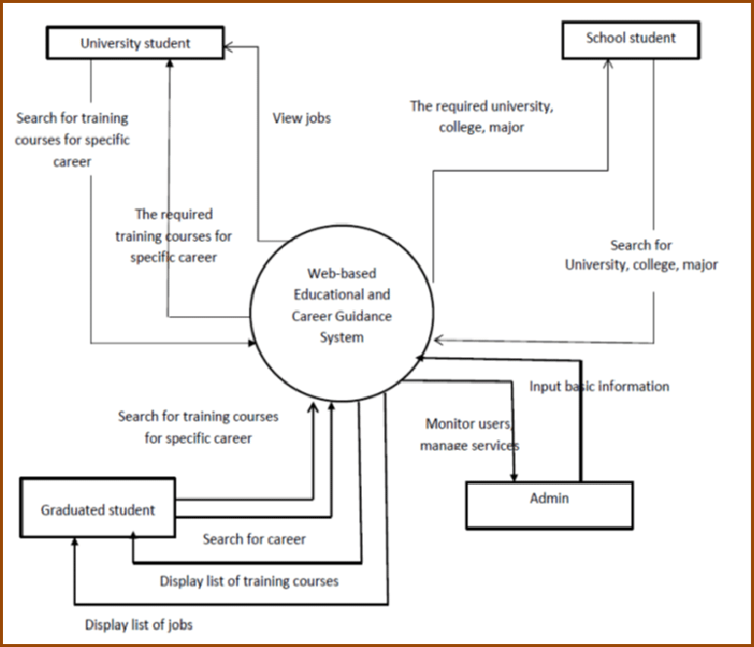

* 1. **ADMIN LEVEL**

Data flow diagram is the starting point of the design phase that functionally decomposes the requirements specification. A DFD consists of a series of bubbles joined by lines. The bubbles represent data transformation and the lines represent data flows in the system. A DFD describes what data flow rather than how they are processed, so it does not hardware, software and data structure.

A data-flow diagram (DFD) is a graphical representation of the "flow" of data through an information system. DFDs can also be used for the visualization of data processing (structured design). A data flow diagram (DFD) is a significant modeling technique for analyzing and constructing information processes. DFD literally means an illustration that explains the course or movement of information in a process. DFD illustrates this flow of information in a process based on the inputs and outputs. A DFD can be referred to as a Process Model.

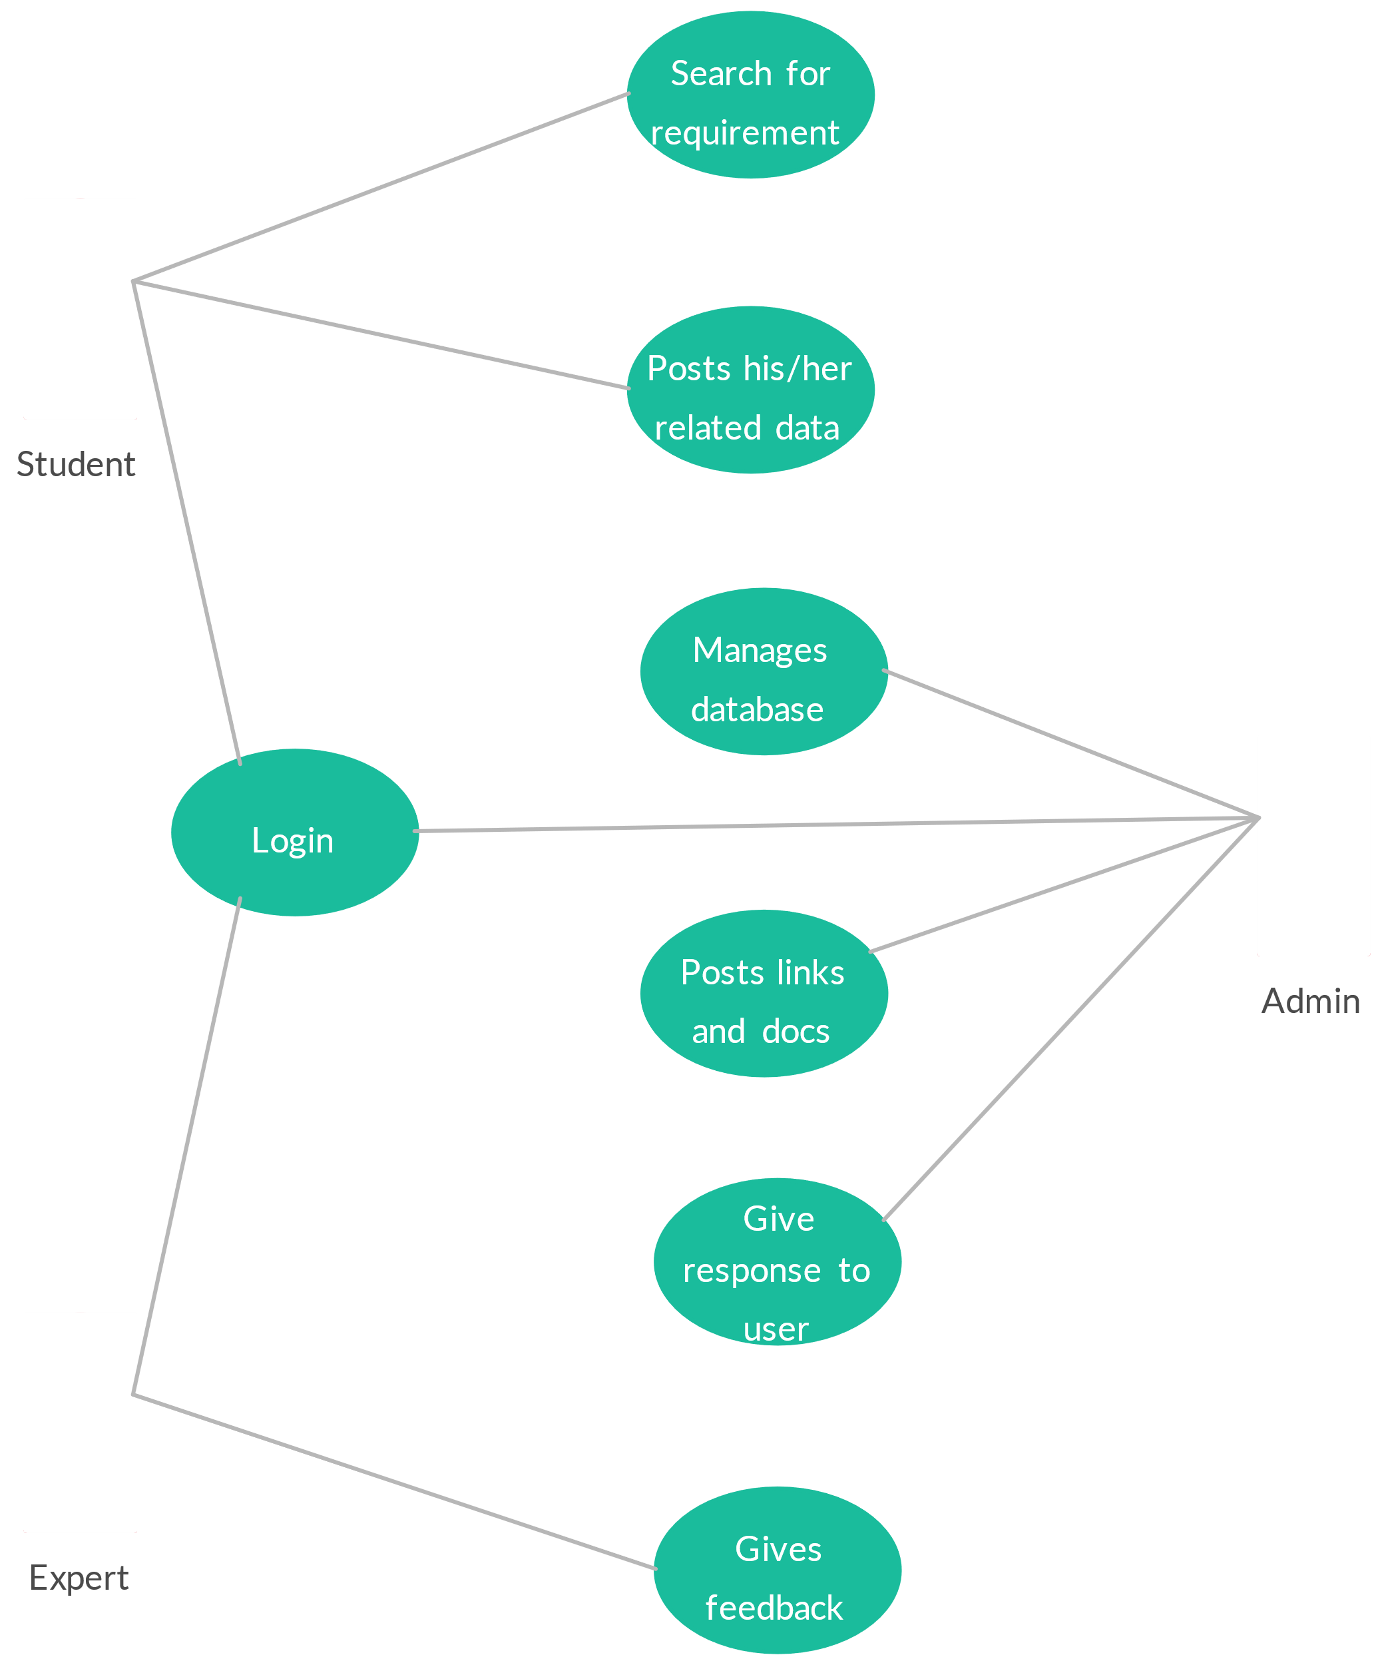

### USER LEVEL DED

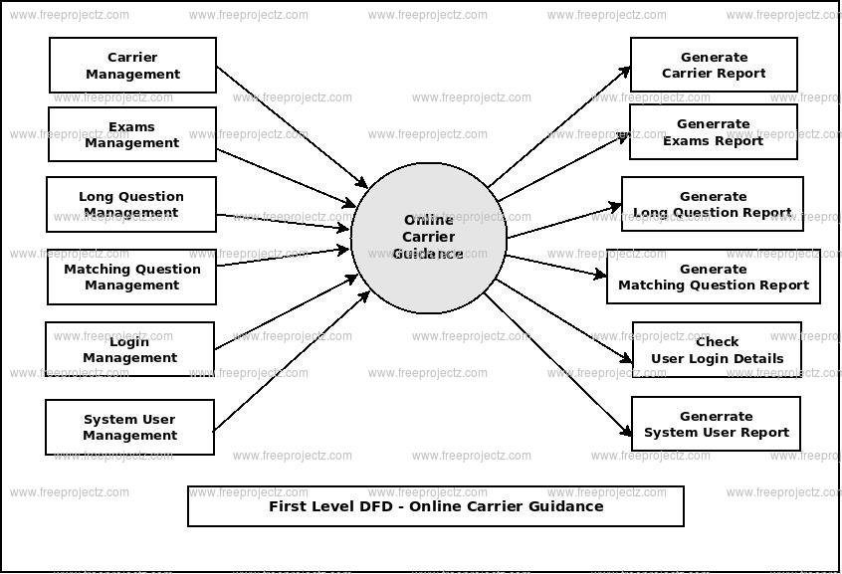

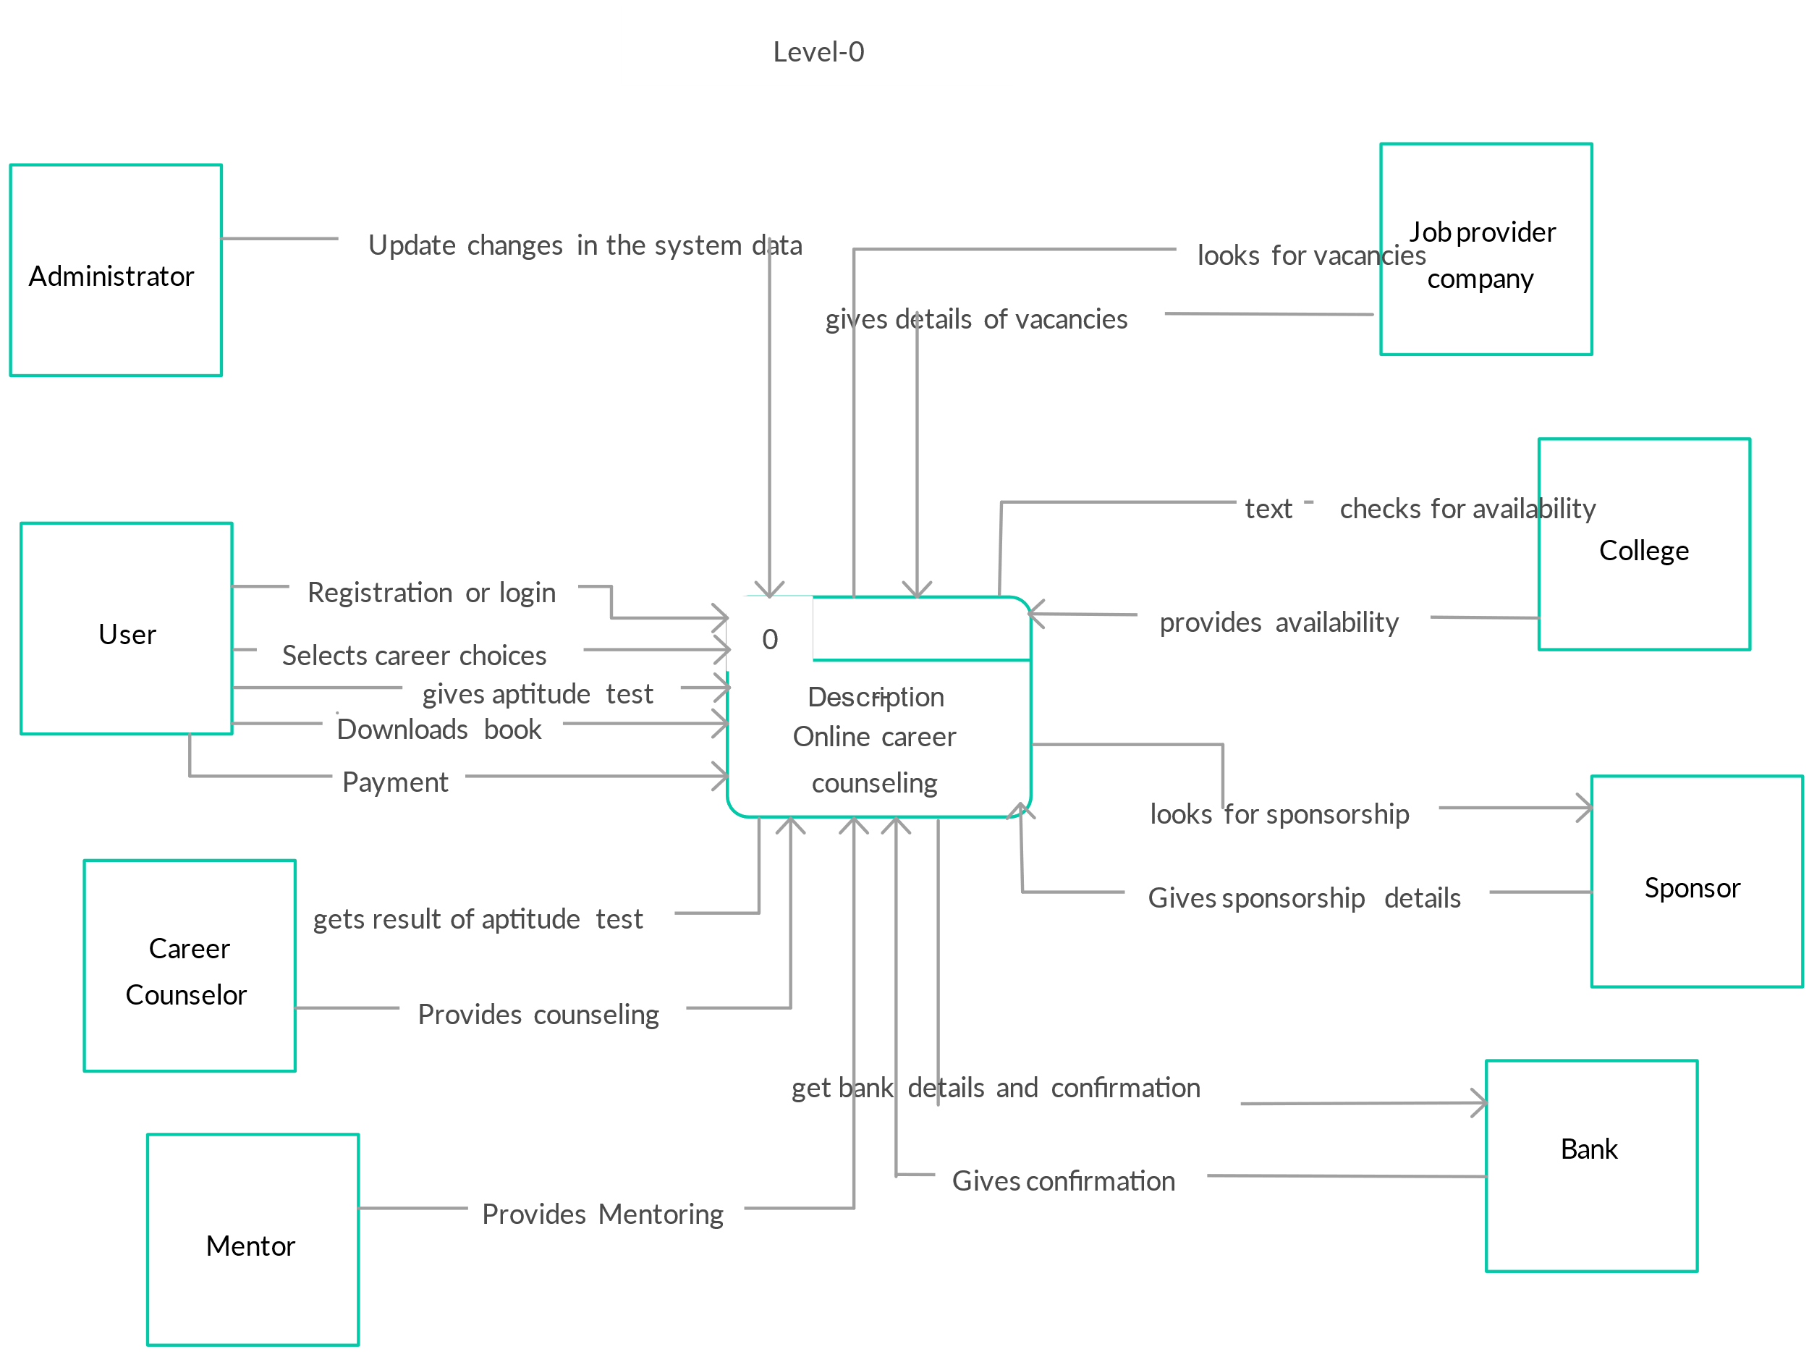**WEBSITE DATA FLOW DIAGRAM DESCRIPTION**

# CHAPTER 7

# SYSTEM WORKING

System analysis is a process of gathering and interpreting facts, diagnosing problems and the information about the Travel Website to recommend improvements on the system. It is a problem solving activity that requires intensive communication between the system users and system developers. System analysis or study is an important phase of any system development process. The system is studied to the minutest detail and analyzed. The system analyst plays the role of the interrogator and dwells deep into the working of the present system. The system is viewed as a whole and the input to the system are identified. The outputs from the organizations are traced to the various processes. System analysis is concerned with becoming aware of the problem, identifying the relevant and decisional variables, analyzing and synthesizing the various factors and determining an optimal or at least a satisfactory solution or program of action. A detailed study of the process must be made by various techniques like interviews, questionnaires etc. The data collected by these sources must be scrutinized to arrive to a conclusion. The conclusion is an understanding of how the system functions. This system is called the existing system. Now the existing system is subjected to close study and problem areas are identified. The designer now functions as a problem solver and tries to sort out the difficulties that the enterprise faces. The solutions are given as proposals. The proposal is then weighed with the existing system analytically and the best one is selected. The proposal is presented to the user for an endorsement by the user. The proposal is reviewed on user request and suitable changes are made. This is loop that ends as soon as the user is satisfied with proposal. Preliminary study is the process of gathering and interpreting facts, using the information for further studies on the system.

Preliminary study is problem solving activity that requires intensive communication between the system users and system developers. It does various feasibility studies. In these studies a rough figure of the system activities can be obtained, from which the decision about the strategies to be followed for effective system study and analysis can be taken.

CARRER GUIDANCE MANAGEMENT SYSTEM can help users find career advice, find a job, or connect with career advisors and companies. A CARRER GUIDANCE MANAGEMENT SYSTEM can include:

* **Tests and quizzes**

To help users determine their best career choice, a CARRER GUIDANCE MANAGEMENT SYSTEM can include tests and quizzes related to career and personality.

* **Information**

A CARRER GUIDANCE MANAGEMENT SYSTEM can provide users with information about themselves and the world around them.

* **Communication**

A CARRER GUIDANCE MANAGEMENT SYSTEM can allow users to communicate with each other, such as students with career advisors, or companies with job seekers.

* **Control system**

A CARRER GUIDANCE MANAGEMENT SYSTEM can include a control system to protect the system from unnecessary activities.

* **User interfaces**

A CARRER GUIDANCE MANAGEMENT SYSTEM can include different user interfaces for different types of users, such as students, school parties, and industries.

Here are some other aspects of career guidance:

* **Career guidance is a process**

Career guidance is a process that helps people find the right career for them, but it's not a one-step process.

* **Career guidance helps people become self-aware**

Career guidance helps people understand their strengths and weaknesses, and how to make up for their weaknesses.

* **Career guidance helps people plan occupational goals**

Career guidance helps people take actionable steps to plan their occupational goals.

* **The history of career guidance**

The first formal vocational guidance bureau was created in 1908 by Frank Parsons.

The aim of proposed system is to develop a system of improved facilities. The proposed system can overcome all the limitations of the existing system. The system provides proper security and reduces the manual work.

* Security of data.
* Ensure data accuracy's.
* Proper control of the higher officials
* Minimize manual data entry.
* Minimum time needed for the various processing.
* Greater efficiency.
* Better service.
* User friendliness and interactive.
* Minimum time required.

**CHAPTER 8**

**PROBLEM IDENTIFICATION AND PROPOSED WORK**

**8.1 Problem Identification**

In today’s rapidly evolving job market, students face significant challenges in making informed career choices. The lack of personalized guidance often results in confusion and anxiety regarding future career paths. Traditional methods of career counseling, such as one-on-one sessions with counselors, are often limited in their effectiveness due to factors like time constraints, a lack of resources, and the inability to tailor advice to individual needs. Additionally, many students are unaware of emerging career opportunities or the skills required for various professions, leading to mismatched career choices that can have long-term repercussions on their job satisfaction and career success.

Moreover, educational institutions often lack an integrated system to track student interests, skills, and academic performance. This gap hinders the ability to provide data-driven recommendations for career paths, resulting in missed opportunities for students to explore fields aligned with their strengths and interests. Furthermore, many existing career guidance systems are not user-friendly and fail to engage students effectively, leading to low utilization rates.

The transition from education to the workforce is a significant milestone for individuals. However, many face challenges in making informed career decisions due to various factors:

1. Lack of Guidance and Information:
   * Limited access to comprehensive career information and guidance.
   * Difficulty in understanding career paths and requirements.
   * Lack of awareness about emerging industries and job trends.
2. Self-Assessment Limitations:
   * Challenges in accurately assessing personal strengths, weaknesses, interests, and values.
   * Difficulty in identifying suitable career paths aligned with individual profiles.
3. Inefficient Career Counseling:
   * Limited availability of qualified career counselors.
   * Inefficient and time-consuming traditional counseling methods.
   * Lack of personalized guidance and support.
4. Complex Job Market:
   * Rapidly evolving job market with changing industry demands.
   * Difficulty in navigating job search platforms and understanding recruitment processes.
   * Challenges in building a strong professional network.
5. Limited Career Development Opportunities:
   * Lack of resources and support for continuous learning and skill development.
   * Difficulty in identifying relevant training programs and certifications.

**8.2 Proposed Work**

To address these challenges, a robust Career Guidance Management System (CGMS) is proposed. This system will provide a comprehensive solution to empower individuals in making informed career decisions.

Key Features and Functionalities:

1. User Registration and Profiling:
   * Create user accounts for students, professionals, and counselors.
   * Collect and store detailed personal and academic information.
   * Utilize advanced algorithms to identify individual strengths, weaknesses, interests, and aptitudes.
2. Career Assessment Tools:
   * Implement a variety of assessments, such as aptitude tests, interest inventories, and personality questionnaires.
   * Provide real-time feedback and personalized insights based on assessment results.
   * Offer a range of assessment options to cater to diverse learning styles and preferences.
3. Comprehensive Career Information Database:
   * Curate and maintain a vast repository of information on various career paths.
   * Provide detailed descriptions of different professions, including job roles, educational requirements, salary ranges, and industry trends.
   * Offer resources such as industry reports, case studies, and expert interviews.
4. Personalized Career Counseling:
   * Facilitate one-on-one or group counseling sessions with experienced career counselors.
   * Enable virtual counseling sessions through video conferencing and chat features.
   * Provide access to a knowledge base of frequently asked questions and common career dilemmas.
5. College and University Information:
   * Provide information on institutions of higher education, including admission requirements, tuition fees, and scholarships.
   * Offer tools to compare different colleges and universities based on various criteria.
   * Provide guidance on the application process and financial aid options.
6. Job Search and Placement Services:
   * Integrate with job portals and recruitment agencies to provide access to job listings.
   * Offer resume building and interview preparation tools.
   * Provide career networking opportunities and mentorship programs.
7. **User Profiling:**

Students will create detailed profiles that include their interests, academic performance, skills, and career aspirations. This data will be used to generate tailored recommendations for potential career paths.

1. **Skill Assessment Tools**:

The CGMS will include various assessment tools, such as aptitude tests and personality assessments, to help students identify their strengths and weaknesses. These tools will provide insights into suitable career options based on individual capabilities.

1. **Career Exploration Resources:**

The platform will offer a wealth of resources, including information on various industries, job roles, required qualifications, and salary expectations. It will also feature success stories from professionals in different fields to inspire and motivate students.

1. **Mentorship Program:**

The system will facilitate connections between students and industry professionals through a mentorship program. Students will have the opportunity to seek guidance, ask questions, and gain insights from those already working in their desired fields.

1. **Data-Driven Insights:**

Utilizing analytics, the CGMS will monitor trends in job markets and educational outcomes, providing students with up-to-date information about in-demand skills and career prospects. This feature will help students make informed decisions based on real-time data.

1. **User-Friendly Interface:**

To enhance engagement, the CGMS will be designed with an intuitive interface that encourages exploration and interaction. Features such as gamification, progress tracking, and interactive workshops will keep students motivated and involved.

1. **Feedback Mechanism:**

A built-in feedback mechanism will allow users to share their experiences and suggestions, enabling continuous improvement of the system based on user needs.

Expected Outcomes:

* Enhanced Self-Awareness:

Individuals will gain a deeper understanding of their strengths, weaknesses, interests, and values.

* Informed Career Decisions:

Users will be empowered to make informed choices about their career paths.

* Improved Employability:

The system will help individuals develop the skills and knowledge needed to succeed in the job market.

* Increased Career Satisfaction:

Users will be more likely to find fulfilling and rewarding careers.

* Reduced Career Uncertainty:

The system will provide guidance and support throughout the career journey.

By addressing the identified problems and leveraging the proposed solutions, the Carrer Guidance Management System will contribute to a more informed, empowered, and successful workforce.

**CHAPTER 9**

**CONCLUSION AND FUTURE SCOPE**

**9.1 Conclusion**

The development of a comprehensive Career Guidance Management System (CGMS) represents a significant advancement in addressing the complex challenges faced by students in navigating their career paths. By leveraging technology and data-driven insights, the CGMS offers a personalized approach that can effectively cater to the diverse needs of students. The integration of user profiling, skill assessments, mentorship opportunities, and extensive career resources ensures that students are equipped with the necessary tools to make informed decisions about their futures.

The system’s focus on real-time data analytics allows for the continual adaptation of career guidance strategies to align with evolving job market trends and emerging industries. This adaptability is crucial in a world where the nature of work is constantly changing, and new career opportunities arise. Additionally, by fostering a supportive community through mentorship and peer networking, the CGMS encourages students to engage actively in their career development journey, increasing their confidence and motivation.

Moreover, the user-friendly design of the CGMS aims to enhance user engagement and satisfaction. By incorporating interactive features and gamification elements, the platform not only makes the exploration of career options more enjoyable but also encourages regular usage. This ongoing engagement is essential for building a robust understanding of the various career pathways available, as well as the skills and qualifications required to succeed in those fields.

**9.2 Future Scope**

The future scope of the Career Guidance Management System is vast and multifaceted. Here are several potential directions for development:

1. **Integration with Educational Institutions**: Future iterations of the CGMS could involve partnerships with schools, colleges, and universities. By integrating the system within existing educational frameworks, institutions can provide students with seamless access to career guidance, making it a core component of the academic experience.
2. **AI-Powered Personalization**: The incorporation of artificial intelligence (AI) could enhance the personalization aspect of the CGMS. AI algorithms can analyze user data more deeply, providing even more tailored recommendations and identifying patterns in career preferences that may not be immediately apparent.
3. **Expanded Resource Library**: As the job market evolves, so too should the resources available on the CGMS. Expanding the library to include online courses, webinars, and workshops focused on skill development can help students gain the practical knowledge needed to pursue their chosen careers effectively.
4. **Virtual Reality (VR) and Augmented Reality (AR)**: Future versions of the CGMS could incorporate VR and AR technologies to provide immersive experiences of different work environments. This would allow students to explore careers in a more interactive and engaging way, helping them visualize themselves in various roles.
5. **Global Reach and Cultural Adaptation**: As the system evolves, expanding its reach to include international students can foster a more inclusive platform. Adapting the content and resources to reflect cultural nuances and regional job markets will enhance the system’s relevance and effectiveness worldwide.
6. **Continuous Feedback Loop**: Implementing a robust feedback mechanism will allow users to continuously contribute to the evolution of the system. By actively seeking input from students and industry professionals, the CGMS can remain current and effective, adapting to new challenges and opportunities in career guidance.
7. **Long-Term Career Tracking**: Future developments could include features that allow users to track their career progress over time, providing insights into the effectiveness of their career choices and the evolving skills needed in their fields.

.

# SCREENSHOTS:

